Phenolic Exterior Wall Cladding

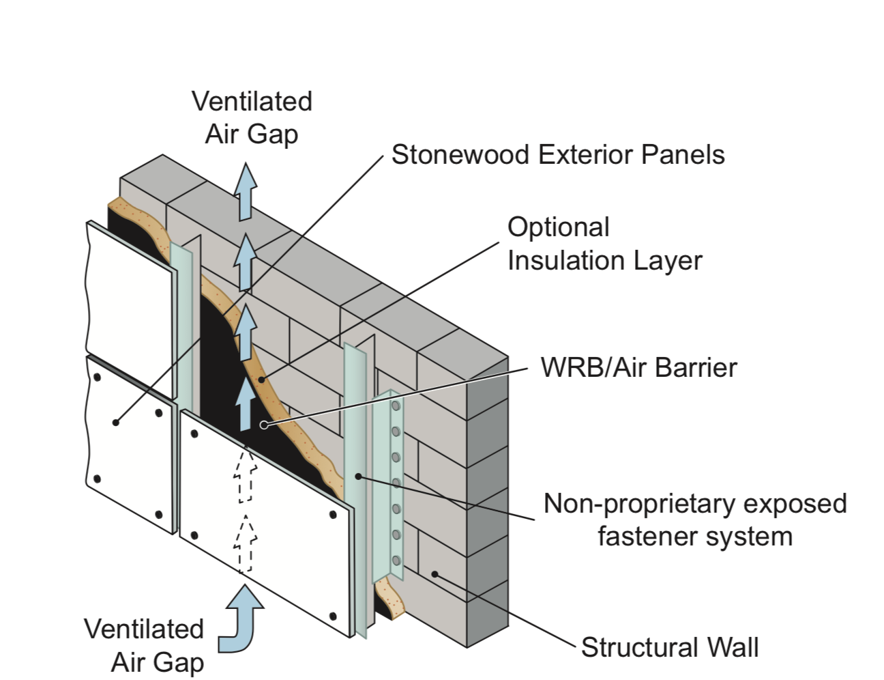

SECTION 07 42 43
COMPOSITE WALL PANELS

This specification includes hidden text for editing for a project.

- - GENERAL

  - SUMMARY

    - Section Includes:

Phenolic wall cladding panels.

Attachments and fasteners.

  - RELATED SECTIONS
    - Division 01: Administrative, procedural and temporary work requirements.
    - [Section 06 10 00 - Rough Carpentry] [_____________]
    - [Section 06 15 00 – Wood Decking] [__________]
    - [Section 06 20 00 – Finish Carpentry] [_________]
    - [Section 07 05 43 – Cladding Support Systems] [__________]
    - [Section 07 21 00 – Thermal Insulation and Accessories] [________]
    - [Section 00 00 00 - ________________]
  - ACTION SUBMITTALS

A. Shop Drawings: Include plans, elevations, and details, size and layout panels, flashing, rainscreen airflow, supports and attachments.

B. Product Data: Technical data, physical properties and installation instructions for each component.

C. Color Charts: Manufacturers standard color options.
D. Samples: Submit manufacturers finished samples [3-inch x 3-inch showing available colors] [12-inch x 12-inch in specified color]
E. Warranty:
1. Manufacturer’s warranty certificate.
2. Installers written warranty statement.
  - INFORMATIONAL SUBMITTALS

A. Installer: Installation experience statement.

B. Testing and Evaluation Reports: Independent testing laboratory for the following for ASTM E84 and NFPA 285.
  - QUALITY ASSURANCE
    - Manufacturer Qualifications:
      - Minimum of [10] years successful experience producing phenolic materials.
      - [Produce FSC (®FSC-C115183) certified materials]
      - Domestic factory assembly, shop fabrication and pre-finishing
    - Installer Qualifications:
      - Minimum 2-years [documented] installation experience of specified materials.
    - Single Source Responsibility:
      - Materials from a single manufacturer for each component and warranty.

D. Pre-Installation Conference: Convene to review the following:
1. Areas of installation.
2. Framing and rough carpentry.
3. Connections to adjacent surfaces and transitions.
4. Structural requirements and anchoring locations.

E. Mock-Up:
1. [Full-size] or [8-foot x 8-foot] or [_____] mockup erected at site, to verify color, workmanship and installation details as determined by architect.
2. Complete assembly, color, sheen and model.
  - FIELD CONDITIONS

    - Do not install panels on wet or frozen substrate.
  - DELIVERY, STORAGE, AND HANDLING
    - Deliver, store, and handle materials following manufacturer instructions.
    - Immediately upon delivery notify manufacturer of damaged or defective materials for replacement.
      - Verify manufactures labels meet approved product name, color, texture and finish.
    - Store factory sealed materials indoors, above grade and protected from sun, weather and materials that could cause staining or discoloration of finish.
      - Maintain humidity levels less than 65 percent relative humidity prior to installation.
  - WARRANTY

A. Manufacturer to warrant against material defects and manufacturing tolerances for a period of 10-years.
B. Installer to warrant against installation defects for a period of [2] [4]-years. Repair or replace materials during warranty period at no cost to Owner.

- - PRODUCTS
  - MANUFACTURERS

    - Basis of Design: Fiberesin Industries, Inc. N48W37031 E. Wisconsin Avenue, Oconomowoc, WI: (262) 567- 4427 www.stonewoodpanels.com; email: info@fiberesin.com

    - Substitutions: [Not permitted.] [Refer to Division 01.]
  - MATERIALS
    - Phenolic Exterior Wall Cladding: Solid phenolic laminate panel with UV protective clear coat.
      - Style: [_______]
Color: [_____]
      - Install Pattern: [Running bond] [25-percent running bond] [50-percent running bond] [Stack bond]
      - Finish: Factory #60 matte
      - Thickness: [5/16 inch (8mm)] [3/8 inch (10mm)] [1/2 inch (13mm)]
      - Panel Core: Phenolic resin treated layer, black and natural brown kraft paper.
      - Decorative Layer: Melamine resin, proprietary pigmented and treated.
      - Weather and UV Resistant Layer: 2-mil, proprietary layer combining pigment protection, Ultraviolet
light and weather resistant layer.

B. Physical Properties
1. Flexural Strength, ASTM D790
a. Machine Direction: 16,000 psi
b. Cross Direction: 12,000 psi
2. Flexural Modulus, ASTM D790
a. Machine Direction: 1,500,000 psi
b. Cross Direction: 1,100,000 psi
3. Tensile Modulus, ASTM D638
a. Machine Direction: 15,000 psi
b. Cross Direction: 10,000 psi
4. Fastening Strength, ASTM D1761:

a. [730 pound-force] [1,260 pound-force] [1,700 pound-force]
5. Structural Performance: Withstand design wind load based on building code, but not less than 23psf with maximum L/180 tested to ASTM E330.
6. Fire Performance:
a. Flame Spread/Smoke Developed: [Class A,] [Class B,] tested to ASTM E84
c. Ignition Temperature: Greater than 650 degrees F (350 degrees C) above ambient, tested to
ASTM D1929.
d. Extended Surface Burn: Max Flame Front less than 10 feet, tested to ASTM E2768

e. When required for compliance with local building codes, wall assemblies shall not ignite when exposed to a radiant heat energy source, NFPA 268
f. When required for compliance with local building codes, wall assemblies shall meet performance requirements of NFPA 285
7. Finish Performance:
a. Humidity Resistance: No cracking, checking, crazing, erosion, delamination, distress, tested to
ASTM D2247.
b. Salt Spray Resistance: No cracking, checking, crazing, Erosion, Delamination, or distress, tested to
ASTM B117.
c. Weather Exposure: Maximum gray scale change of 3-4 according to DIN EN 438-2 when tested to ASTM D2244 at accelerated – 3000 Hours in Atlas Type Weatherometer using cycle of 102 minutes light and 18 minutes diminished light and demineralized water.

  - FABRICATION

A. Panels: Solid phenolic impregnated kraft paper wall panels with no voids, air spaces or foamed insulation in the
core material.
B. Panel Dimensions: Field fabrication shall be allowed where necessary but, shall be kept to an absolute minimum.
All fabrication shall be done under controlled shop conditions when possible.

C. Fabrication Tolerances: Manufacturer to provide shop fabrication and pre-finishing for a warranted finish.
1. NEMA Testing Results
a. Dimensional Change, 3.11 test
1. Length (Machine Direction): 0.25 percent
2. Width (Cross Direction): 0.50 percent
b. Weight Per Unit Area:

1. Pounds/ square feet: [2.23] [2.68] [3.58]
2. Kilograms/ square meter: [10.93] [13.12] [17.49]
3. Density: 86 pounds per cubic foot
  - ACCESSORIES

    - Fasteners: Manufacturer approved austenitic stainless-steel fastener with bi-metal welded carbon steel point.
      - [Concealed fasteners] [Exposed fasteners in [standard stainless steel] [____color] finish]

    - Attachment System: Manufacturer approved sub-frame system to support a cladding weight of up to 8 pounds per square foot, fabricated of 0.09-inches 6063 T5 extruded aluminum or 16-gauge G90 Galvanized steel.
      - [Exposed faster mounting] [Concealed fastener mounting System] [Stack plank mounting system] [Clip
plank mounting system] [Vertical siding mounting system]

    - Weather Barrier: Specified in [____________]

- EXECUTION
  - EXAMINATION
    - Examine materials, installation instructions, and review manufacturer’s instructions on site.
    - Verify panel style, color, and fasteners are approved by Architect.
    - Verify substrates and adjacent surfaces are level and plumb for installation.
      - Do not begin work until construction has progressed to allow installation of materials.
      - Confirm sheathing is plumb and level, with no deflection greater than 1/4- inch in 20 feet.
      - Verify manufacturers fastener spacing requirements.
      - Verify proper hole diameter in panels per manufacturer’s instructions.
    - Proceed with work when construction has progressed to allow a warranted installation.
      - Installation deems acceptance of work for a warranted installation.
  - INSTALLATION
A. Install in accordance with manufacturer’s instructions and Shop Drawings, maintaining required 1-inch ventilation spacing requirement.

B. Fasten panels to an approved attachment system structurally supported by aluminum, galvanized steel or wood stud supported wall.

C. Install panel square, edges clean and true to size.
1. Cut panels to fit at perimeter and around penetrations with minimum 3/8-inch gap.
2. Re-chamfer field cut edges.

D. Do not install damaged, irregular or defective panels.
  - FIELD QUALITY CONTROL
    - Inspect panel ventilation at top and bottom of wall for proper vertical air flow required for rainscreen systems.
    - Comply with manufacturer’s written installation instructions applicable to products and applications indicated.
    - Verify installation, fasteners and connections with adjacent materials, and transitions have been completed in accordance with shop drawings.
    - Installer is responsible for engineering the connection between the Stonewood system and the supporting wall.
  - ADJUSTING
    - Modify, adjust and replace panels not within manufacturer’s tolerances and as required by Architect.
  - PROTECTION

A. Protect surface, corners and components from damage prior to Owner occupancy using temporary protection.

END OF SECTION

